SeaPerch – Remotely Operated Vehicle (ROV)
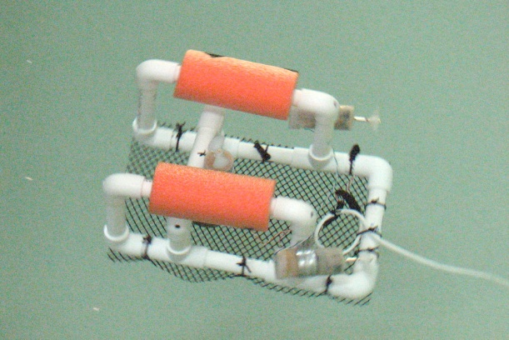
You and your group are working together to construct an ROV. This submarine must be complete and fully functional by the given time frame. This challenge must be met using all the members of your group, which means EVERYONE must be involved and productive. As you already know, there are only enough materials to complete the ROV and there are no extra pieces to replace mistakes (so please do not make any).
You will receive an individual and a group grade for the completion of the ROV and this form.
Working Plan:
Be sure to write out the working plan for your group.
What are the three main parts of the ROV construction?
1.
2.
3.
Which student is doing each part?
1.
2.
3.
Who was the team captain/co-captain?
- & -
List of materials/resources you used:
Please list of the materials and resources you utilized in order to construct the ROV:
Evaluation:
Write 3 paragraphs describing the ROV project on a separate piece of paper (TYPED):
- What did you learn?
- What problems did you have to overcome?
- What can be improved?

Completion of the SeaPerch (write answers on this paper in complete sentences):
How did your working plan turn out in actuality? Can things be done any better? Or did your plan work?
Reflection of working plan

How is the quality of construction and functionality? Do all 3 motors work appropriately? Is your control box fully functional? Is your structure solid and functional?
Completion check list

How did your team work/collaborate? Was there one or more people not fully participating in the process? Would you change any of the dynamics of the group?
Team work

Was every part of the construction safely done? Were you concern about safety at all (explain)?
Safety

Extension:
You work for a company that constructs ROV’s. Your boss just told you that you have to design a vehicle for the next field testing season. The company does not have a very large budget, so you cannot build a new ROV for this project. You need to alter the design of your existing Sea Perch ROV.
Recognize an existing problem/condition underwater that they would like to investigate.
- Identify what equipment would be needed to add to Sea Perch in order to collect data or analyze the identified problem/condition.

- Plan out – to scale – what the modification design will look like

- Show/demonstrate their designs to other students.

- Critique each other’s design.

- Search the Internet for needed information, save web addresses, collect information and save.

You will receive a separate grade for these modification plans! The following three criteria will be used for your grade:
- Rough draft of drawing completed on time
- Modification clearly explained
- Presentation to others
SeaPerch Skills
Please reflect on the experience of building the SeaPerch and mark which skills were new to you and which ones were mastered this time around.
Skill | New Skill | Mastered skill (review)
Soldering
Measuring
Drilling
Pipe-cutting
Waterproofing
Stripping wires
Assembling propeller
Producing Neutral Buoyancy
Maneuvering ROV
Teamwork

CATEGORY | Proficient with Distinction - 4 | Proficient - 3 | Partially Proficient - 2 | Substantially Below Proficient - 1
Construction -Materials | Appropriate materials were selected and creatively modified in ways that made them even better. | Appropriate materials were selected and there was an attempt at creative modification to make them even better. | Appropriate materials were selected. | Inappropriate materials were selected and contributed to a product that performed poorly.
Modification/  testing | Clear evidence of troubleshooting, testing, and refinements based on data or scientific principles. | Clear evidence of troubleshooting, testing and refinements. | Some evidence of troubleshooting, testing and refinements. | Little evidence of troubleshooting, testing or refinement.
Function | Structure functions extraordinarily well, holding up under atypical stresses. | Structure functions well, holding up under typical stresses. | Structure functions pretty well, but deteriorates under typical stresses. | Fatal flaws in function with complete failure under typical stresses.
Safety | ALWAYS demonstrates understanding of and observes all tool safety points: clean work areas, pays attention to surroundings, wear goggles when appropriate, No loose clothing, jewelry, and long hair. | OFTEN demonstrates understanding of and observes all tool safety points: clean work areas, pays attention to surroundings, wear goggles when appropriate, No loose clothing, jewelry, and loose long hair. | SOMETIMES demonstrates understanding of and observes tool safety points: clean work areas, pays attention to surroundings, wear goggles when appropriate, No loose clothing, jewelry, and long hair. | DOES NOT demonstrates understanding of and/or observes tool safety points.
Group participation | Contributed exceptional effort to the group’s project. * Did a fantastic job in organizing group efforts and keeping people on track. * Went above and beyond the call of duty to further group’s work. | Contributed great effort to the group’s project. * Did a good job of organizing group efforts and keeping people on track. * Completed his or her share with great effort. | Contributed good effort to the group’s project. * Was helpful and cooperative in completing his or her share | Rarely contributed to the group’s project; often needed to be begged to focus and produce; frequently off task; distracted group.
Class participation | Attends all but one or two class sessions. Exhibits positive, supportive attitude toward course and class members. | Participation is as good as one receiving a Exemplary rating, but one or two elements are not quite a distinguished level. | Participation is generally similar to one receiving an Apprentice rating, but there are one or two elements which are relatively well done. | Does not attend class on consistent basis. Does not contribute to class discussions or in-class activities.

