Name ___________________________ Date ____________ Class ______________

NOTE: goggles, apron must be worn during this investigation!!

QUESTION:
Can you identify the energy change of a chemical reaction?

OBJECTIVES:
- Compare and Contrast exothermic and endothermic reactions.
- Classify the chemical reactions (synthesis, decomposition, and single displacement, double displacement, and combustion reactions).

Safety Precautions
Warning: Some of the substances used are poisonous. Dispose of the reactions mixture and products as instructed by your teacher. Goggles, apron, and gloves must be worn during this investigation!!

Reaction #1
Materials: 10 cm x 10 cm piece of corrugated cardboard, 250mL Erlenmeyer flask, 32 g Ba(OH)₂∙ 8H₂O, 15g NH₄SCN

1. Procedure:
1. Place the 32 g of barium hydroxide in the Erlenmeyer flask.
2. Take the initial temperature of the material in the flask before the next step. 3. Wet the cardboard with water and place the Erlenmeyer flask on it. (You should have a puddle of water on the surface of the cardboard).
4. Add the ammonium thiocyanate crystal to the flask.
5. Stopper the flask and agitate it until the two chemicals are mixed. After 5 minutes, measure the temperature again. Record your observations (by answering the questions below)!

a. What did you observe?

b. How can you tell if energy was lost or gain?

Equation:
Ba(OH)_{2·} 8H₂O_{(s)}+ 2NH₄SCN_{(S)} + energy →2NH_{3(g)}+ Ba²⁺_{(aq)} +2SCN⁻_{(aq)}+ 10H₂O_{(l)}

- Was there a precipitate produced by this reaction? If not how do you know?

- What information allows you to identify what type of reaction was going to take place? Classify the reaction: Endothermic or Exothermic. Explain your answer:

- On the last page, draw a graphic “potential energy diagram” for this reaction.

Sample graphs: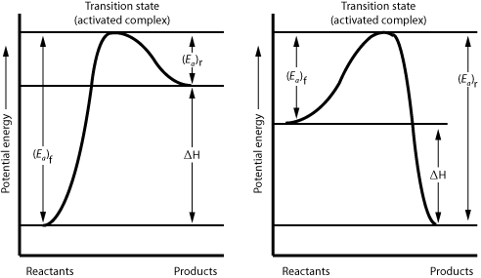

Reaction #2
Materials: 50ml of 30 % hydrogen peroxide (H₂O₂) solution, saturated potassium iodide (KI) solution, liquid dishwashing detergent, food coloring, 500 ml graduated cylinder, splint (optional).

Safety: wear disposable gloves and safety glasses. Oxygen is evolved in this reaction, so do not perform this demonstration near an open flame. Also, do not lean over the graduated cylinder when the solutions are mixed. Leave your gloves on following the activity to aid with cleanup. The solution and foam may be rinsed down the drain with water.

2. Procedure:
- Put on gloves and safety glasses. The iodine from the reaction may stain surfaces so you might want to cover your workspace with an open garbage bag or a layer of paper towels.
- Pour 50 ml of 30% hydrogen peroxide solution into the graduated cylinder.
- Squirt in a little dishwashing detergent and swirl it around.
- You can place 5-10 drops of food coloring along the wall of the cylinder to make the foam resemble striped toothpaste.
- Measure the initial temperature of the mixture.
- Add 10 ml of potassium iodide (KI) solution (a catalyst). Do not lean over the cylinder when you do this, as the reaction is very vigorous and you may get splashed or possibly burned by steam.
- You may touch a glowing splint to the foam to relight it, indicating the presence of oxygen.
Measure and record the final temperature after 5 minutes. Record you observations!!

Equation: (balance it!)
2H₂O_{2(aq)}→ ____ H₂O_{(l)} + ____O_{2(g)}+ energy

- What information allows you to identify what type of reaction was going to take place? Classify the reaction: Endothermic or Exothermic. Explain your answer:

- In the back of this page, draw a graph for “potential energy diagram” for this reaction.

Sample graphs:

Inquiry component:
How could you make the exothermic reaction hotter?

How could you make the endothermic reaction colder?

Design an experiment to test your ideas about endothermic and exothermic reactions. We MAY perform it as a class. Please be sure to be specific.

