OBJECTIVE: to practice reading, interpreting, and making line graphs

Graphs are visual representations of a set of data. In this activity, you will examine, interpret, and create line graphs. A line graph shows how changes in one variable are linked to changes in another variable. It is often used when one of the variables is continuous, such as time. When you have completed the activity, scroll down and answer the questions below.

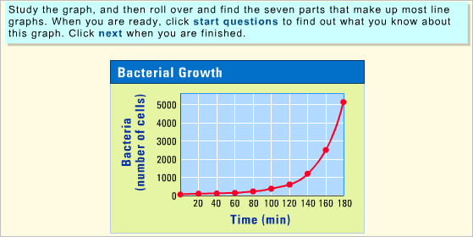
Answer the following questions in the boxes provided.

1. Why would you use a line graph to show the distances thrown for javelin during several Olympics?

2. What does each data point on a line graph represent?

3. Define a "best fit" line and describe what a scientist can learn from it.

