Name: _________________________________ Date: ___________

Analyzing Data
1. An experiment studies the effects of an experimental drug on the number of offspring a mother mouse has. 10 female mice are given the drug and then impregnated. The number of mice in their litters is compared to the litters of mice that did not take the drug.
Number of Babies in Litter
Group A  (drug) | 5 | 6 | 4 | 8 | 5 | 2 | 7 | 12 | 12 | 8
Group B  (control) | 4 | 4 | 6 | 6 | 5 | 6 | 4 | 7 | 5 | 3
Based on the data, what would you conclude about the drug, did it work?

2. Cow Growth Rates
A type of feed claims to boost the growth rate of cows. The feed is tested on two twin newborn cows. Bessie receives the experimental feed, and Bertha receives regular corn feed. Their weights are recorded below.
Month | April | May | June | July | Aug
Bessie | 150 lbs | 210 lbs | 260 lbs | 320 lbs | 400 lbs
Bertha | 150 lbs | 250 lbs | 290 lbs | 340 lbs | 400 lbs
Graph the data; use a dotted line for Bessie and a straight line for Bertha. Make sure you label the X and Y axis.
Both cows ended at the same weight, but did the experimental feed change the way they gained weight at all? Describe your conclusions about the experimental feed and explain why it is important that the experiment used twin cows?

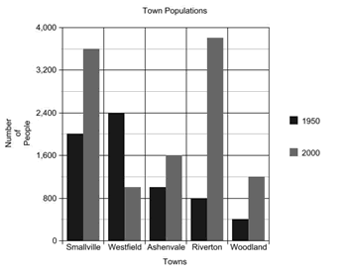
3. Town Populations Graph
a. According to the graph, which town grew the fastest?
b. Which town declined in population?
c. Which town had the smallest change in population?
d. What is the population of Woodland in 2000?

4. Insect Graph
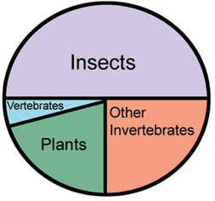
a. According to the graph, which group of organisms has the most number of species?

b. What is the total percentage for all invertebrates?
c. Approximately what percentage are vertebrates?

5. Tiger Shark Population
The population of tiger sharks off the coast of Florida was recorded over several months. Graph the tiger shark populations below.
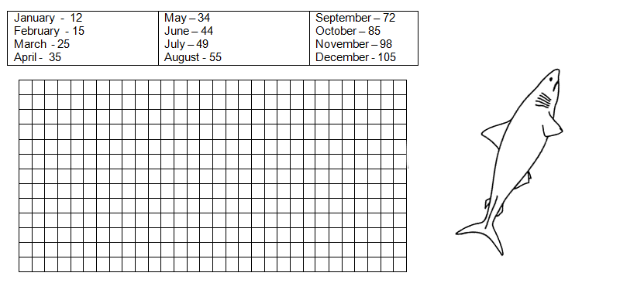

The number of nurse sharks was also recorded for this time period; though the person recorded the number was not as reliable as the person recording tiger shark numbers. The following data was taken on nurse sharks. Use a different color to graph the nurse shark population on the graph above.
March - 60 | April - 52 | July - 38 | August - 20 | November- 14 | December - 11
a. At what month would you expect the number of nurse sharks to equal the number of tiger sharks?
b. What does the graph tell you about the trends of both shark populations?

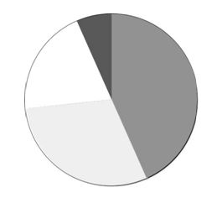
1. A class survey revealed that out of 30 students, 13 listed their favorite lunch item as pizza, 9 chose cheeeseburgers, 6 picked lasagna, and 2 chose tacos.

Label the pie graph.

2. Jamie bought a new video game and decided to keep track of his scores.
Try 1 – 150 pts Try 2 – 190 pts
Try 3 – 500 pts Try 4 – 900 pts
Try 5 – 1100 pts Try 6 – 1500 pts
Create a graph of Jamie’s progress. Put the “trys” on the X axis
3. Jamie’s friend, Josie tries out the same game.
Try 1 – 100 pts Try 2 – 500 pts
Try 3 – 900 pts Try 4 – 1100 pts
Try 5 – 1400 pts Try 6 -- 1500 pts
Use the same graph and draw an another line to represent Josie’s scores – Label each line as Jamie or Josie.
4. Based on your graph, who is the better player? Justify your answer.

5. Take a class survey about favorite colors. Find out what your classmates’ favorite colors are using the list below. Create a bar graph that is color coded that compares the class choices
Blue ________________
Red ________________
Green _______________
Yellow _______________
Purple _______________
Pink ________________
Orange _______________

