FINGERPRINT-CHAPTER 14

On surface of your fingertips are raised lines called friction ridges.

Fingerprints:

In 1880 Francois Galton recognized that ridge patterns are different from person to person.

He determined that these fingerprints can be used as a means of personal identification.

His work is the basis for our current system of fingerprint classification.

Fingerprint analysis: 1) Classification

2) Development

1) Classification of Fingerprints/exercises-activities: Balloon Prints; Graphite Prints; Inked Prints; Fingerprint Comparison and Classification

2) Development Latent Fingerprints /exercise-activities: Iodine Fuming; Fingerprint Powder; Superglue Fuming of Small Items; Superglue fuming of large Items.

Analysis:

- Inked Fingerprints: Inked prints are collected directly from an individual’s hand
- Latent Prints: are developed on a surface, documented via photographs, and lifted via varying techniques.

Note: The individuality of a fingerprint is not determined by its general shape or pattern but by a careful study of its ridge characteristics (minutiae)

It is identity, number, and relative locations of characteristics such as:

- RIDGES
- RIDGE ENDINGS
- BIFURCATIONS
- ENCLOSURES
- RIDGE ISLAND (RIDGE DOTS)

FINGERPRINTS ARE DIVIDED: -LOOPS (65% of population)

-WHORLS (30-35% of population) →Plain, Central pocket, Double loop, Central

-ARCHES (5% of population) →Plain arches and tented arches.

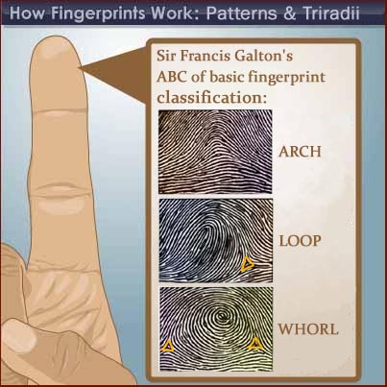

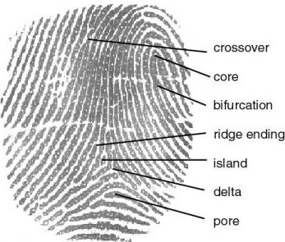

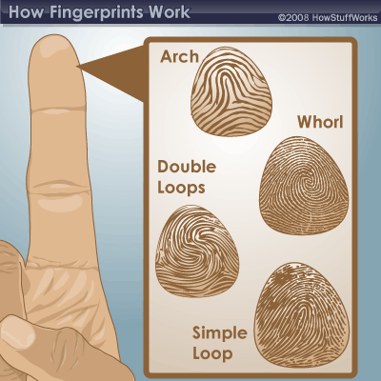

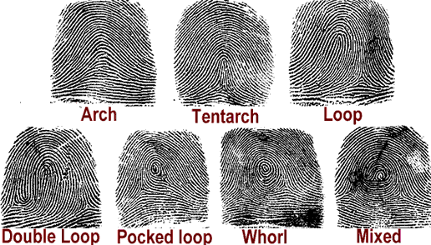

After studying this chapter you should be able to:

- Know the common ridge characteristics of a fingerprint
- List the three major fingerprint patterns and their respective subclasses
- Distinguish visible, plastic, and latent fingerprints
- Describe the concept of an automated fingerprint identification system (AFIS)
- List the techniques for developing latent fingerprints on porous and nonporous objects
- Describe the proper procedures for preserving a developed latent fingerprint.

Fingerprints are some of the most important and useful pieces of forensic evidence collected by the forensic scientist. Individual prints are unique. Fingerprint types are inherited, but exact patterns are not. Compare your prints to those of your parents and siblings. No two persons’ fingerprints are alike, not even identical twins. This fact allows a person’s fingerprints to be considered as direct evidence for identification.

Three main fingerprint patterns are found in the human population—arch, loop, and whorl. Approximately 69% of all prints are loops. The rarest type of fingerprint is the arch, making up approximately 6% of the total population. That leaves about 25% of the population as whorls. Each of these groups is subdivided. Look at the following examples.

http://www.youtube.com/watch?feature=player_embedded&v

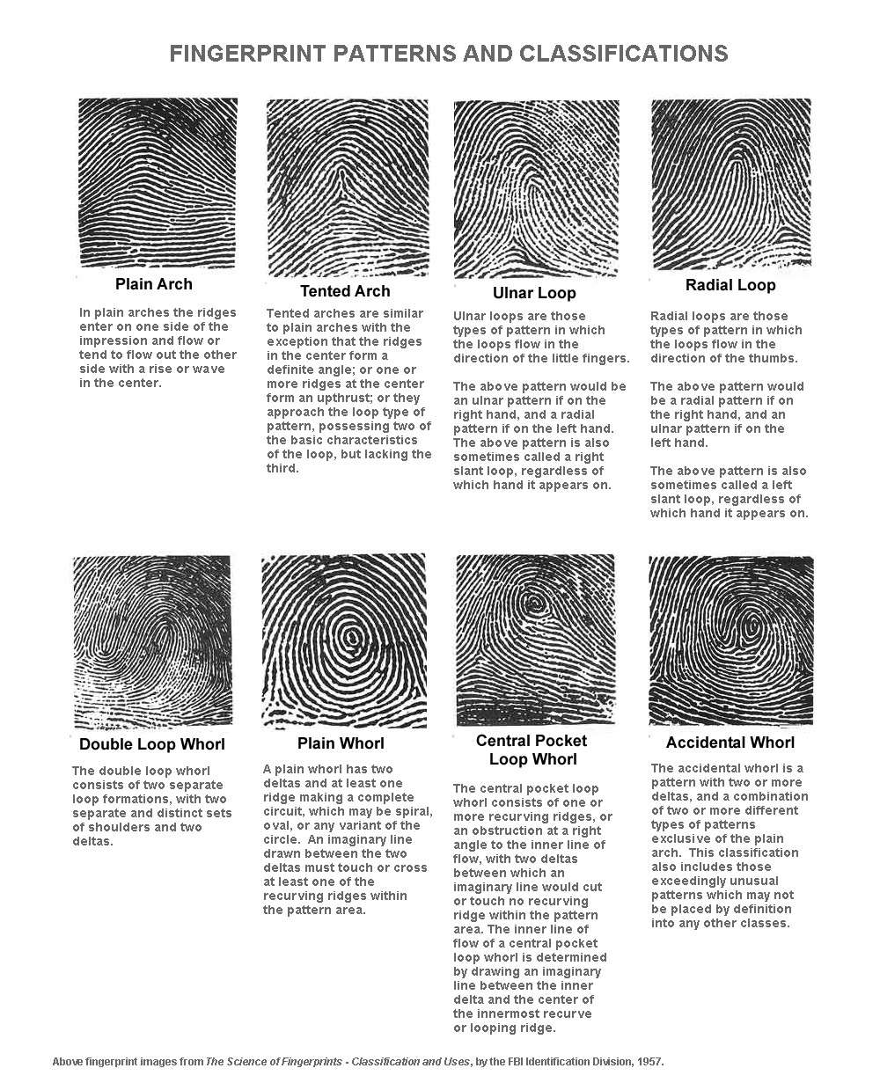

Arches
The plain arch consists of simple ridges that flow from left to right, with a rise or hill in the center. The tented arch appears to have a ridge that supports the arches like the center post in a tent.

Loops
There are three parts of a loop pattern: deltas, typelines, and looping. Loop patterns always develop ridges that separate to form a delta. All loops must have at least one delta. The ridges that separate or diverge at the delta are typelines. The third part of a loop pattern is the looping. Loops must have at least one curving and returning ridge. They may have as many as 20. In a loop pattern, ridges flow from one side with a rise. Then, they curve and return to the same side from which they started.

Whorls
Unlike arches and loops, whorls are often unique. Whorls are ridge patterns that have a mini- mum of two deltas.
Plain whorls are target-shaped patterns with two deltas. An imaginary line connecting the two deltas must cross at least one circle.
Central pocket loop whorls must have at least one circle and two deltas. An imaginary line connecting the two deltas must not cross the circle between the deltas.
Double loop whorls must have two separate loop formations inside two delta formations.
Accidental whorls are unusual patterns with three deltas or a combination of a loop and a tented arch.

Procedure for Lifting Fingerprints
The three types of fingerprints are visible, impressions, and latent. If liquids, such as paint or blood, are part of the crime scene, fingerprints may be visible. In this case, the investigator photographs the prints and catalogs the photograph as part of the evidence.
More frequently, fingerprints are not visible. Impressions can become visible if special lighting techniques are used. Then the prints can also be photographed. Latent prints, however, are hidden. Latent prints occur because fingers sweat, even if they feel cool and dry.
Sweat is mostly water, which will evaporate, leaving behind organic compounds such as amino acids, glucose, lactic acid, and peptides or inorganic salts of potassium or sodium chloride. These trace compounds form latent prints.

Method 1
The simplest and most frequently used method of revealing a fresh fingerprint is to dust it with a black powder. This powder is composed of a colorant and a resinous polymer or inorganic salt. The resinous polymer or inorganic salt is absorbed by the moisture or oil of sweat, and the colorant is adsorbed on the resin or salt.
A black powder that can be used to dust for fingerprints can be prepared as follows.
1. Place 3 g of charcoal powder, 9 g of zinc carbonate, and 0.1 g of talcum powder in a mortar and pestle. Grind the mixture to a fine powder.
2. Add 20 g of fine iron fillings and grind again.
3. Place the powder in a tightly sealed, labeled bottle.

Test your product by taking a clean, dry beaker and pressing your fingers around the outside. Dip a small brush into your powder, and lightly dust the prints. You may either photograph or lift the print. To lift a fingerprint, take a wide piece of clear tape and press it firmly over a print. Rub the back of the tape, and then carefully lift it. Fasten the tape to a 3′′ x 5′′ index card.

Method 2
If the print is older and most of the water and oils have evaporated, you still may be able to find a latent print. Ninhydrin is an organic compound that reacts with amino acids to form a deep purple complex. Make a solution of ninhydrin by mixing 0.5 g ninhydrin with 30 mL of ethanol. Pour the solution into a spray bottle. Hold the bottle about 15 cm away from where you think the print might be, and spray a light coat on the area. Wait a few moments until much of the ethanol evaporates, then spray again. Allow the area to dry completely. The print will appear only when the area is completely dry. You may use a hair dryer to help dry the area. This method works well on papers, such as on forged checks, where latent prints are normally difficult to lift.

