FORENSIC BIOLOGY
DNA is located in the _______of a cell.
- Mitochondria
- Golgi apparatus
- Nucleus
- Vesicles
All of the following would have different DNA, EXCEPT:
- mother and daughter
- fraternal twins
- an older brother and a younger brother
- identical twins
Forensic biologists compare DNA samples by looking at how many markers?
- 7
- 10
- 13
- 21
The PCR technique:
- makes DNA grow a lot faster than it usually does
- makes millions of copies of the DNA markers
- uses a machine to match two DNA profiles
- is part of the Extract step of DNA analysis
The four steps of DNA processing are:
- Extract, Sort, Analyze, Compare
- Extract, Amplify, Separate, Analyze
- Duplicate, Separate, Analyze, Sort
- Extract, Amplify, Assemble, Compare
TOXICOLOGY LAB
Vitreous humor is found in the:
- nose
- elbow
- knee
- eye
What does SCREENING test accomplish?
- tells you what specific drug was in the victim
- finds evidence by looking inside the stomach
- checks for the presence or absence of chemicals
- tests whether you should be a toxicologist or not
What happens to a chemical when it is analyzed by the Gas Chromatography/Mass Spectrometer (GC/MS)?
- It is broken into fragments which are each counted to create a graph
- It dissolves in a liquid which then is tested with iodine
- It is added to other chemicals to create a chemical reaction
- It is vaporized to analyze the chemical as a gas
A mass spectrum of a chemical:
- will match the mass spectra of other chemicals
- will be unique, unlike the mass spectrum of any other chemicals
- is very small and must be duplicated several times to be analyzed
- is not a reliable way to compare chemicals
How do CSIs ensure that evidence does not get tampered with?
- Everyone promises to not contaminate the evidence
- A security guard watches the evidence box at all times
- No one is allowed to handle the evidence except the Supervisor
- Anytime someone examines evidence, they must sign a Chain of Custody form
What is a positive control?
- a sample prepared by the toxicologist which has a specific chemical present
- a sample prepared by the toxicologist that does not have any chemicals in it
- a sample with any chemical in it
- a sample with human blood
FIREARMS AND TOOLMARKS
The _______marks the bullet with the gun’s unique characteristics.
- Magazine
- Firing pin
- Prime
- Rifling
What is the caliber of this bullet?
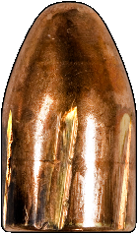
- 9mm
9mm
20mm
Weight = 115 gr.
- 20mm
- 115 gr.

Where do investigators test fire a suspected gun in order to get individual characteristics of the gun?
- In an iron box
- In a water tank
- In a big empty room
- In a steel tube
What equipment do investigators use to analyze striations on bullets?
- Light table
- Magnifying glass
- Comparison microscope
- Super-glue fuming chamber
A 9mm bullet was collected from the victim, and two firearms were found at the crime scene. Both gun 1 and gun 2 use 9mm bullets. How can the investigators determine which gun fired the bullet?
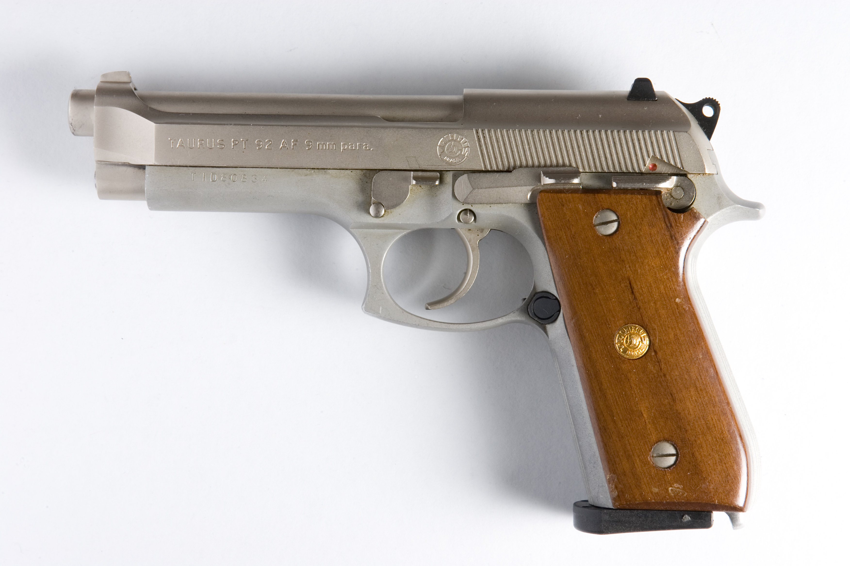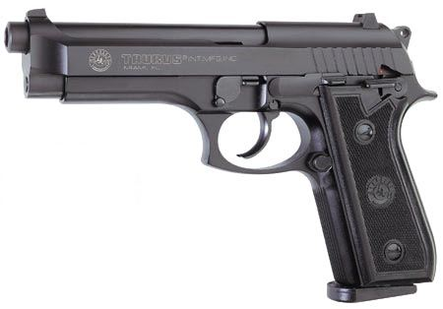
Taurus gun 1 Taurus gun 2

- Compare the fingerprints on the bullet with those found on gun 1 and gun 2
- Identify the rifling pattern on the bullet and match it to gun 1 and gun 2
- Contact the gun manufacturers, and see which one also produces the same type of bullets
- Test fire the suspected guns and compare the bullet striations to the fatal bullet.
MEDICAL EXAMINER
Which of the following is NOT determined by a medical examiner?
- Cause of death
- Manner of death
- Time of death
- Place of death
An internal autopsy always begins with a ___________.
- T-incision
- Y-incision
- X-incision
- Z-incision
During an autopsy, the examiner sticks the syringe into __________to collect a blood sample for further analysis.
- The liver
- The stomach
- The heart
- The lungs
The term “rigor mortis” refers to:
- The death of a person.
- The Latin word for “responsible for death.”
- The body’s muscles stiffening after death.
- The body temperature of a deceased person.
Where does a medical examiner measure the body temperature of a dead person?
- The ear
- The arm
- The liver
- The forehead
There are three important things a medical examiner looks for when determining the time of death. Which is NOT one of them?
- Odor mortis
- Algor mortis
- Livor mortis
- Rigor mortis

