Blue Planet – Seas of Life
Coral Seas

- As you watch the introduction sequence, list three abiotic factors in this ecosystem.

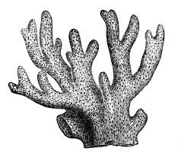
- A keystone species is one that plays a critical role in maintaining an ecological community. Would you classify the coral polyps as a keystone species? Explain why or why not.

- How would you classify the relationship between the algae and the coral polyps?
Hint: Choose from predator-prey, interspecific competition, intraspecific competition, mutualism, parasitism, or commensalism.

- Which abiotic factor is the critical factor in the growth of the coral polyps?

- How would you classify the relationship between the butterfly fish and the coral polyps?

- Why is it an evolutionary advantage for the coral polyps to only come out at night?

- How would you classify the relationship between the coral polyps and the plankton?

- How would you classify the relationship between the different species of coral?

- How would you classify the relationship between coral and the crown-of-thorns starfish?

- How would you classify the relationship between coral and the small crabs?

- How would you classify the relationship between parrotfish and coral?

- Jacks and silversides are a good example of an evolutionary arms race between predators and prey. Describe the predatory adaptations of the jacks, and the defensive adaptations of the silversides.

  - Jacks –

  - Silversides –

- How would you classify the relationship between the sponge and the shrimp?
Hint: The shrimp consume and live off the sponge.

- How would you classify the relationship between the polychaete worm and the shrimp?

- How would you classify the relationship between the redmouth grouper and lionfish?

- How would you classify the relationship between the powder blue tangs and the convict tangs?

- How would you classify the relationship amongst the white-tip shark individuals?

- The entire group of white-tip sharks engaging in a feeding frenzy would be a _________.
  - Organism c. Community
  - Population d. Ecosystem

- The white-tip sharks, marbled rays, octopus, lobster, eel, basket star, and all the other fish present in the coral reef during the night would be considered a…
  - Organism c. Community
  - Population d. Ecosystem

- Watch the brown sturgeonfish mating ritual. Which males are most likely to pass their traits on to the next generation? How will this affect future populations?

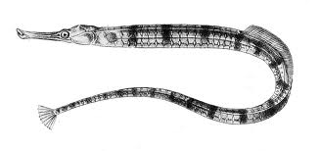
- The banded pipefish shown practice monogamy. How does their sexual behavior provide them an advantage?

- Compare the appearance of the male and female cuttlefish. Why do the male and females look so different, even though they are the same species?

