Blue Planet DVD – Deep Ocean

- Why is a submersible needed to descend to the bottom parts of the ocean?

- As the submersible approaches the twilight zone (300m deep), what changes in light and temperature occur?

- How is the deep sea squid different than its relatives that stay near the surface?

- Hatchet fish are able to make themselves virtually invisible in the dark zone. Describe two specific aspects of their body design that allows this kind of camouflage.

- Why do so many of the animals in the dark zone have red pigment?

- What do animals like the hairy angler depend on instead of sight to locate prey?

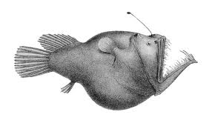
- There are two huge challenges to living in the dark zone: finding food, and a mate. Describe how the deep sea angler accomplishes both.

  - Attracting Prey:

  - Locating a Mate:

- Most of the bioluminescence produced at this level of the ocean is blue. Some predators, however, are able to produce red light. Which is more of an advantage? Why?

- Bioluminescence is also used by prey, such as the shrimp and copepods to escape predators like the gigantocyprus. Describe two examples shown.

- Animals like the firefly squid will migrate up and down the different layers of the ocean depending on the time of day. Explain why.

- Why are there no plants below 500 meters? What do animals at this depth depend on for food instead?

- Why do the echinoderms that live at this depth, such as sea stars and sea urchins, travel in herds?

- The mushroom coral polyps have the largest tentacles of any coral in the ocean. Why is it so important for coral at this depth to have large tentacles?

- What unusual ability do sea cucumbers and polychaete worms have at this depth to help them find food?

- Large predators are rare at this depth, but there are a few. Give on example.

- Hag fish have a mostly cartilaginous skeleton. How do they get enough force to tear flesh from the grey whale carcass?

- What is the depth of the Mariana trench?

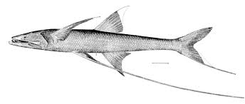
- Tripod fish have two types of specialized fins. Explain where they are, and what they do.

- What unusual ability does the dumbo octopus have that helps it conserve energy?

- Why are the polychaete worms living near the underwater volcanic vent called Pompeii worms?

- The organisms that live around the underwater volcanic vents are completely independent of the sun. What forms the basis of their food web?

- An underwater lake with a sort of tidal action is shown at the bottom of the Gulf of Mexico. How is this possible underwater?

- What does the life in this underwater lake survive on?

