Blue Planet DVD – Coasts

- What abiotic factors are faced by animals and plants living on the coasts?

- Marine Iguanas
- Type of coast: ( Rocky Shore / Sandy Shore )
- One physical adaptation?
- One behavioral adaptation?
- What does it mean to be cold-blooded?
- How does being cold-blooded affect their behavior?

- Waved Albatross:
- Type of coast: ( Rocky Shore / Sandy Shore )
- When do all sea birds have to return to land?
- What is the purpose of the “dancing” that the albatross does?
- How do albatross pairs work together to feed and care for their eggs?

- Sea Turtles
- Type of coast: ( Rocky Shore / Sandy Shore )
- Behavioral adaptation?

- Night herons and pelicans have different shaped beaks. Compare their shape and function:
- Night herons:
- Pelicans:

- What percent of the sea turtle hatchlings actually survive to adulthood?

- How is laying eggs on land an evolutionary advantage for sea turtles and capelin?

- What is the main limiting factor that determines where sea birds nest?

- What type of coast are the sea birds using as nesting grounds?

- Sea birds nest and breed in large groups so that their hatchlings are synchronized. How is this behavior an advantage for them?

- Why does the sea lion hunt seals on land instead of in the sea?

- Prion Birds:
- Physical adaptation?
- Behavioral adaptation?

- What animals can be supported by a single whale carcass?

- Walrus:
- Type of coast: ( Rocky Shore / Sandy Shore )
- Physiologic adaptation?

- Elephant Seals:
- Type of coast: ( Rocky Shore / Sandy Shore )
- Behavioral adaptation?
- Physiologic adaptation?

- The killer whales are shown participating in an extraordinary (and morbid) game of toss. Give what you consider to be the most likely reason why the whales play their game.

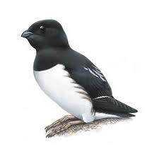
Instructions: Draw an arrow to mark
the location of each of these islands
shown in this episode of Blue Planet.
Funk Island
49°N, 53°W

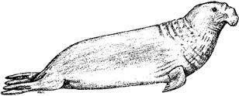
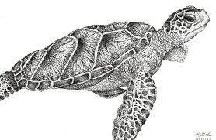
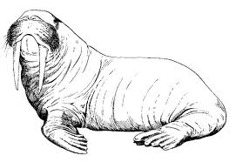
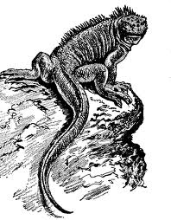
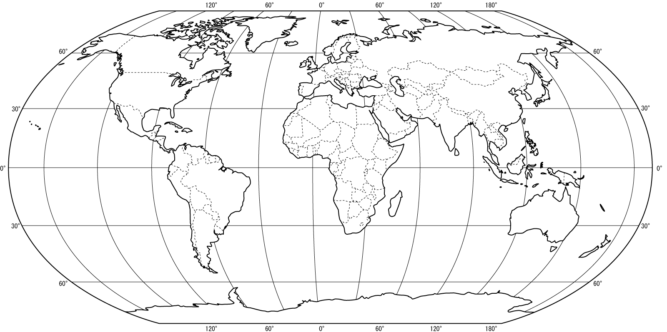
South Georgia Island
54°S, 36°W
South Georgia Island
54°S, 36°W
Ascension Island
7°S, 14°W
Falkland Islands
51°S, 59°W
Galapagos Islands
0°S, 90°W
South Georgia Island
54°S, 36°W
South Georgia Island
54°S, 36°W
South Georgia Island
54°S, 36°W

