Biological Observations
Biology is the study of LIFE! And Life is ALL around us. We will go outside to make some biological observations and then you are going to look up some basic information about your observed species.
You will work in pairs to do the following:
- Find 3 different “kinds” (species) of animals
- Find 3 different “kinds” (species) of plants
- BONUS: At least 1 kind of living organism that is not an animal/plant
- Take a picture/selfie with your 6 (or more) organisms.
- Write down relevant information about your observations (e.g. location, behaviors, etc.) on the table provided on back
- Look up information about each organism and create a way to present this information to the class for a grade using your preferred format (short video, animation, PowerPoint, report, essay, etc.)
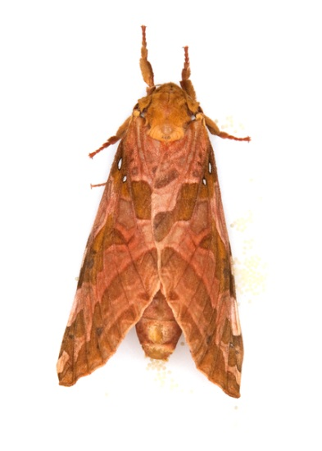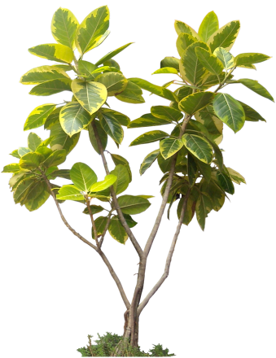
Organism Common name | Location/time of observation | Visual Characteristics and diagram (sketch) | Scientific name | Researched information about organism
Animals

Plants

Other

